The Evolution and Engineering of Aerospace Propulsion: From Reciprocating Engines to Hypersonic Scramjets
PISTON ENGINES
TURBOJET
HIGH BYPASS TURBOFAN
RAMJET AND SCRAMJET
FADEC AND EHM
ARUL

The Evolution and Engineering of Aerospace Propulsion: From Reciprocating Engines to Hypersonic Scramjets
The narrative of human flight is fundamentally a narrative of propulsion. From the moment the Wright brothers first achieved sustained flight in 1903 to the contemporary era of hypersonic research, the progress of aviation has been tethered to the development of power plants capable of overcoming the atmospheric constraints of drag and gravity. The evolution of aircraft engines has not only reshaped global transportation and defense but has also driven unprecedented advancements in materials science, thermodynamics, and digital control systems. To understand the modern jet engine is to understand a machine that operates at the very edge of physical possibility, where components survive temperatures exceeding their own melting points and airflows are manipulated with nanosecond precision.

The Pre-Jet Era: Reciprocating Piston Engines
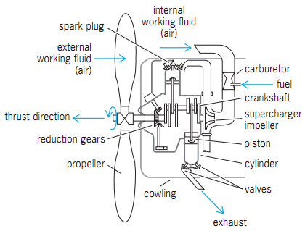
The foundation of aviation was built upon the reciprocating internal combustion engine, a technology that dominated the first four decades of flight. These engines, similar in principle to those found in early 20th-century automobiles, utilized the chemical energy of fuel to drive pistons in a reciprocating motion, which a crankshaft then converted into rotational energy to spin a propeller.

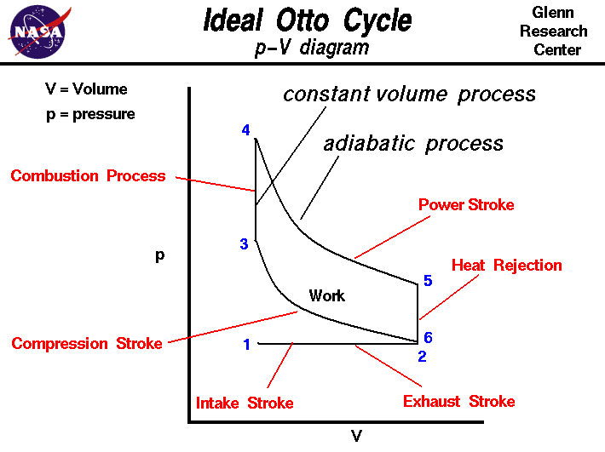
The Four-Stroke Cycle and Propeller Mechanics
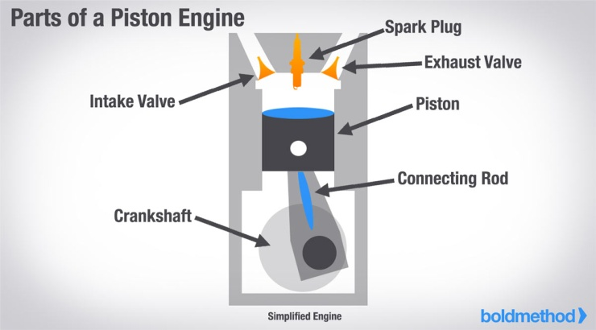
Piston engines in aviation typically operate on the Otto cycle, characterized by four distinct phases: intake, compression, combustion, and exhaust. During the intake stroke, a mixture of air and fuel is drawn into the cylinder. The compression stroke follows, where the piston rises to squeeze the mixture, increasing its energy potential. Ignition by a spark plug initiates the power stroke, where the expanding gases force the piston down, driving the crankshaft. Finally, the exhaust stroke clears the cylinder for the next cycle.
The propeller serves as the propulsor in this system. It functions as a rotating wing, creating a pressure differential that accelerates a large mass of air backward at a relatively low velocity. Modern propeller evolution introduced specialized types to enhance control :
- Constant-Speed Propellers: These automatically adjust blade pitch to maintain a constant engine RPM.
- Feathering Propellers: These can be adjusted to align with the airflow to reduce drag if an engine fails.
- Reverse-Pitch Propellers: These allow for better deceleration and control during landing and ground operations.

Limits of the Reciprocating System
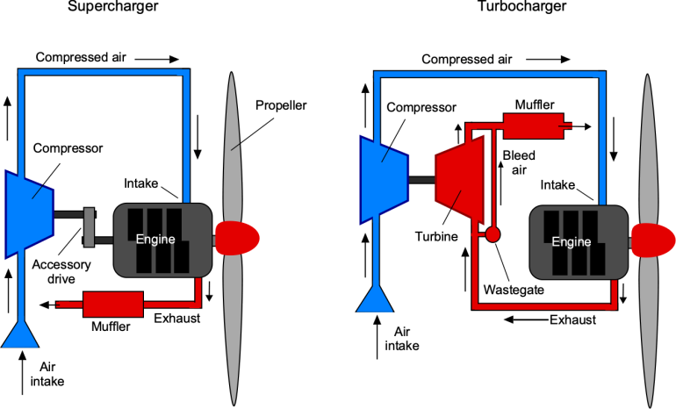
Despite their reliability, piston engines faced a "ceiling" in both altitude and speed. As aircraft reached higher altitudes, the thinning atmosphere provided less oxygen for combustion, requiring complex turbocharging systems. More critically, as aircraft speeds approached the speed of sound, the tips of the propeller blades would often reach supersonic velocities before the aircraft itself. This resulted in shockwaves that dramatically increased drag and decreased efficiency, effectively capping the speed of propeller-driven aircraft.

The Genesis of the Jet Engine: Turbojets
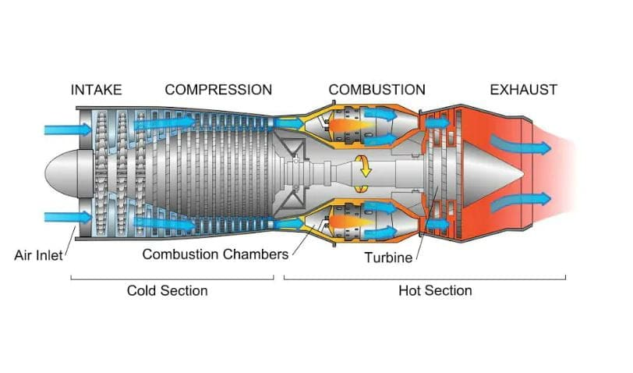
The principle of jet propulsion, demonstrated as early as the first century AD by Hero of Alexandria’s aeolipile, did not become a practical reality for aviation until the 1930s. Sir Frank Whittle in Britain and Hans von Ohain in Germany independently developed the first gas turbine engines suitable for flight.

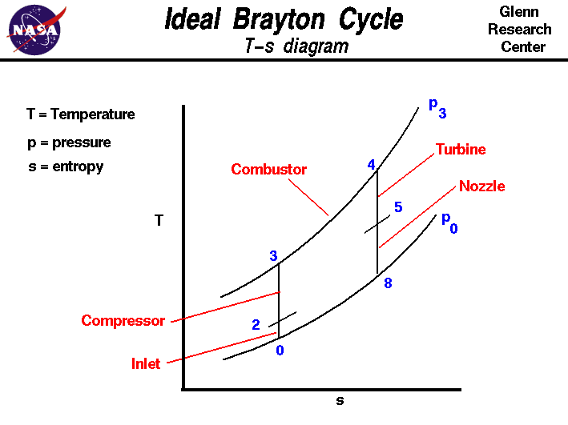
Thermodynamic Principles of the Turbojet
A turbojet is a continuous-flow engine that operates on the Brayton cycle. Unlike the intermittent combustion of a piston engine, a turbojet maintains a steady stream of air through its core. The process follows a path of intake, compression, combustion, and exhaust. In a turbojet, 100% of the air drawn into the engine passes through the combustion chamber. This air is compressed by a series of rotating blades, mixed with fuel, and ignited. The resulting high-pressure, high-temperature gas expands through a turbine—which extracts just enough energy to keep the compressor spinning—and then blasts out of a nozzle at the rear.

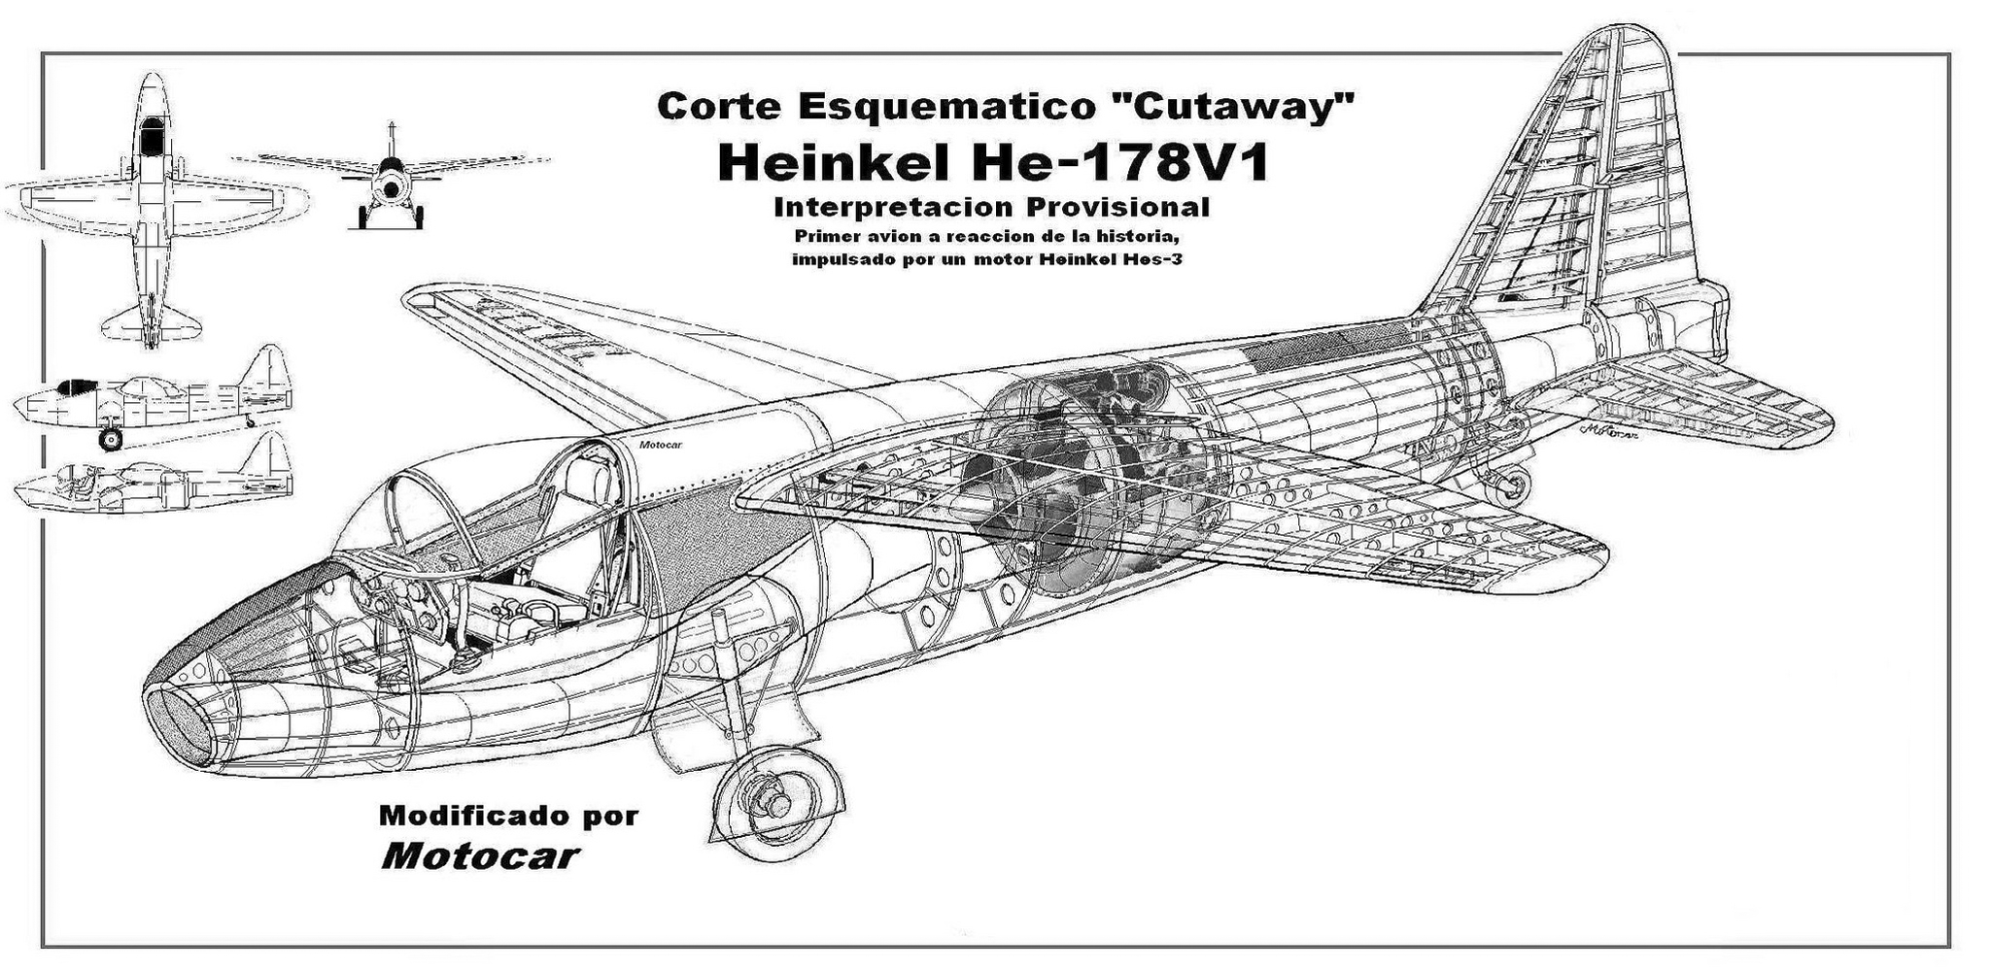
Historical Milestones and Performance
The German Heinkel He 178 achieved the first jet-powered flight in August 1939. By the late 1940s, the turbojet enabled the first commercial jetliner, the de Havilland Comet. Turbojets are highly efficient at high altitudes and supersonic speeds, but they suffer from high fuel consumption (Specific Fuel Consumption or SFC) at lower subsonic speeds compared to modern alternatives.

The Modern Standard: Turbofan Engines
Compressing all the air and putting it all in the combustion chamber and turbines like the turbojet engines makes for quite powerful engines but they are also horribly inefficient. To see why, remember that the impulse pushing the plane forward is equal to the change in the momentum of the air backwards.
So you've got options.
For example, you could push twice as much air back half as fast, or you could push half as much air back twice as fast. Both will generate the exact same impulse, but the kinetic energy of the air is proportional to v squared. So it takes four times as much energy to speed up the air in the second case, and a lot of that energy is just wasted in the exhaust. So, ideally, you want to push as much air backwards as possible with only a small change in velocity.
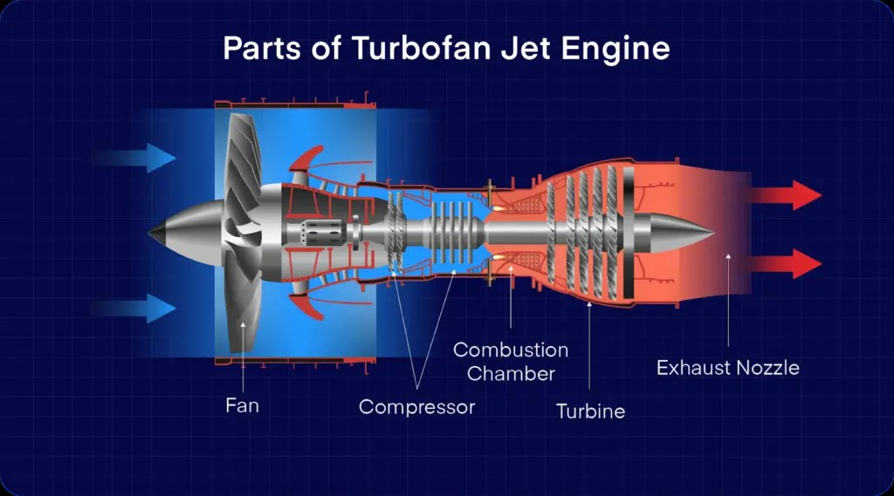
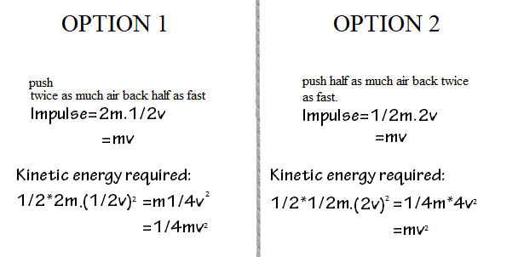 The transition from the turbojet to the turbofan was the most significant leap in commercial aviation efficiency. A turbofan is essentially a turbojet (the core) surrounded by a large fan.

The Mechanism of Bypass Flow
The "bypass ratio" (BPR) is the defining characteristic of the turbofan, calculated as the ratio of air passing around the core to the air passing through it.
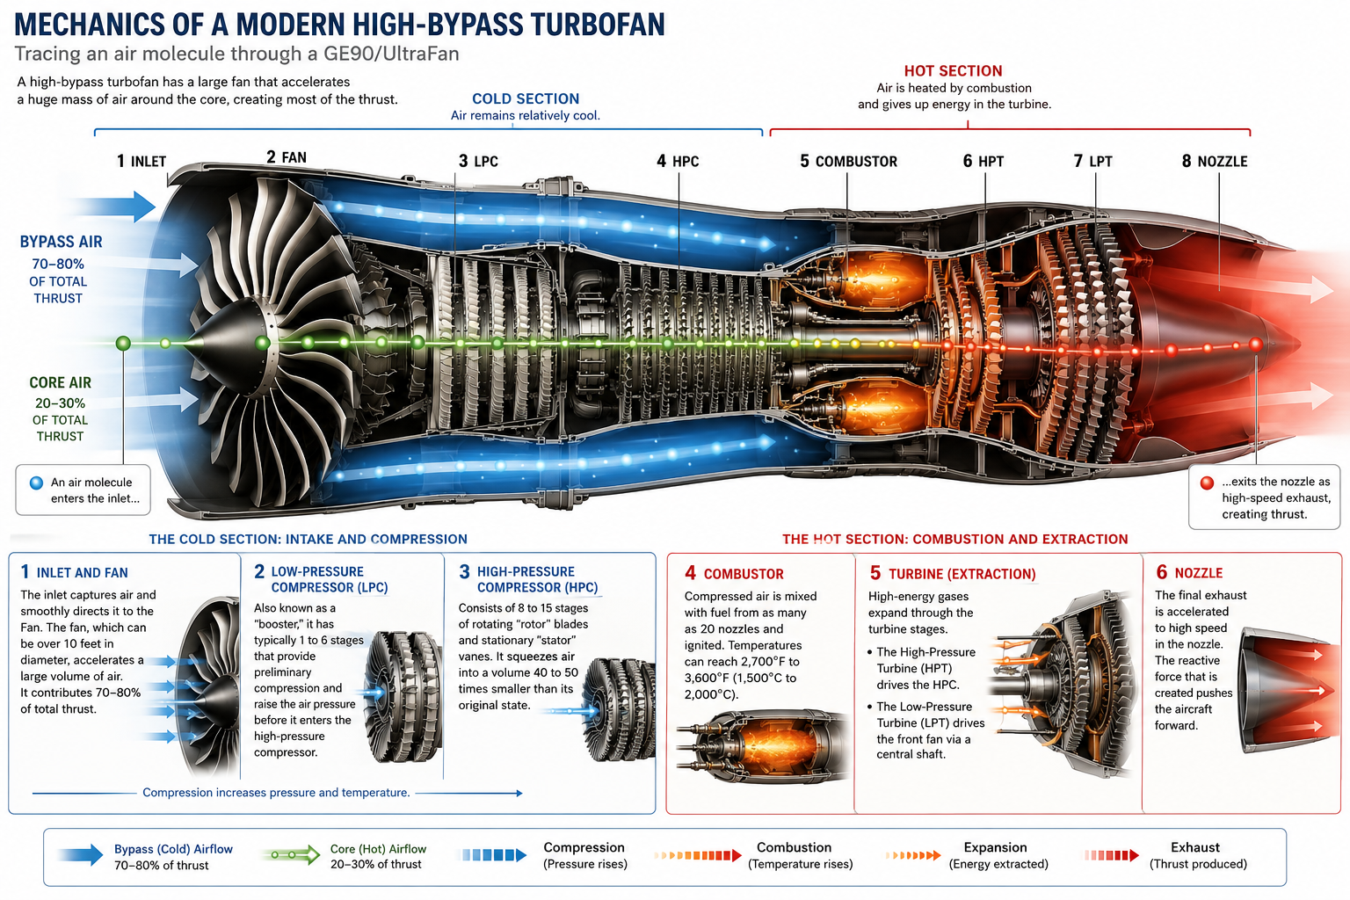
- Core Flow: Passes through the compressor, burner, and turbine to drive the engine.
- Bypass Flow: Accelerated by the large front fan, this air travels through a duct around the core. This large mass of slower-moving air is a more efficient way to generate thrust at subsonic speeds.
Engine Category | Bypass Ratio (BPR) | Performance Advantage
Turbojet | 0:1 | Optimized for supersonic flight; high speed but low efficiency.
Low-Bypass Turbofan | < 2:1 | High thrust for fighters; compact; often uses afterburners.
High-Bypass Turbofan | > 5:1 | High efficiency, low noise; the choice for modern airliners.

Mechanics of a Modern High-Bypass Turbofan
Tracing an air molecule through a modern engine like the GE90 or UltraFan reveals a complex two- or three-spool arrangement.

The Cold Section: Intake and Compression
- Inlet and Fan: The inlet captures air and directs it to the Fan, which can be over 10 feet in diameter and contributes 70-80% of total thrust.
- Low-Pressure Compressor (LPC): Also known as a "booster," it provides preliminary compression.
- High-Pressure Compressor (HPC): Consists of 8 to 15 stages of rotating "rotor" blades and stationary "stator" vanes. It squeezes air into a volume 40 to 50 times smaller than its original state.

The Hot Section: Combustion and Extraction
- Combustor: Compressed air is mixed with fuel from as many as 20 nozzles and ignited. Temperatures can reach 2,700∘F to 3,600∘F (1,500∘C to 2,000∘C).
- Turbine: High-energy gases expand through the turbine stages. The High-Pressure Turbine (HPT) drives the HPC, while the Low-Pressure Turbine (LPT) drives the front fan via a central shaft.
- Nozzle: The final exhaust creates the reactive force that pushes the aircraft.

Facts: The modern Rolls-Royce Trent AWB turbofan engine contains 68 turbines which rotate at 12000rpm and each produce 900 horsepower which is equivalent to a formula 1 race car.

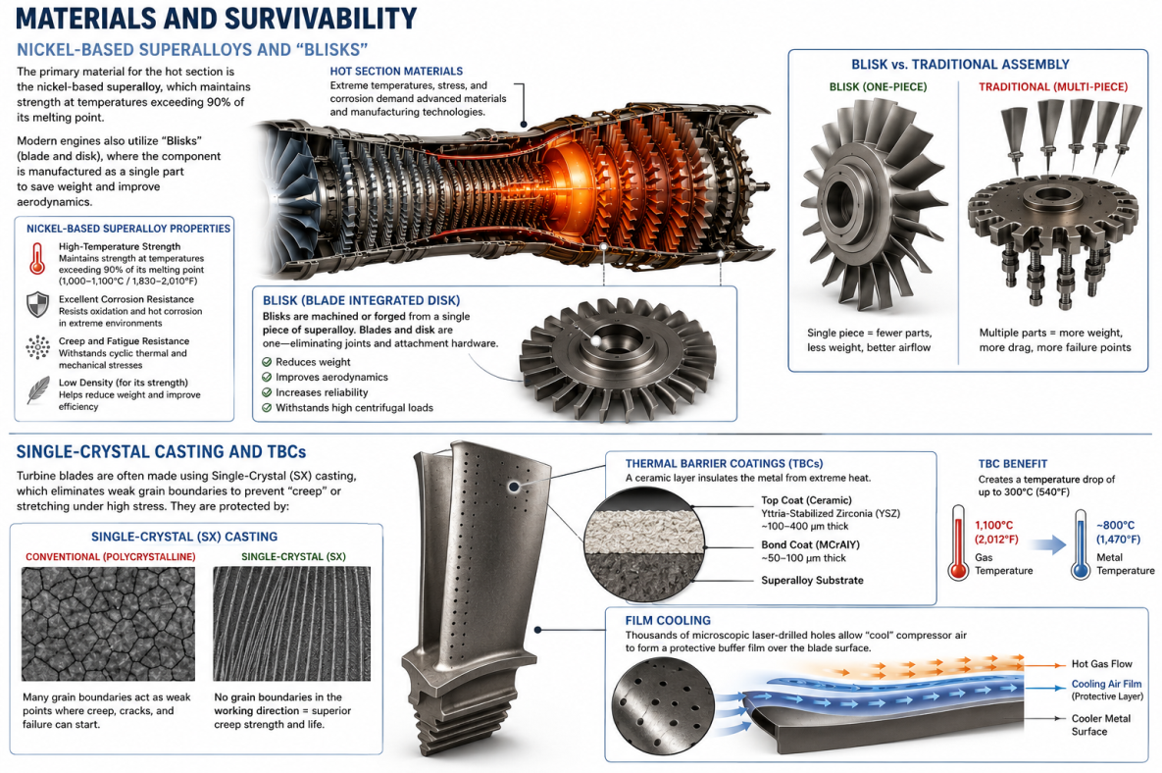
Materials and Survivability

Nickel-Based Superalloys and "Blisks"
The primary material for the hot section is the nickel-based superalloy, which maintains strength at temperatures exceeding 90% of its melting point. Modern engines also utilize "Blisks" (blade and disk), where the component is manufactured as a single part to save weight and improve aerodynamics. Single-Crystal Casting and TBCs
Turbine blades are often made using Single-Crystal (SX) casting, which eliminates weak grain boundaries to prevent "creep" or stretching under high stress. They are protected by:
- Thermal Barrier Coatings (TBCs): Ceramic layers (e.g., Yttria-Stabilized Zirconia) that are only 1/5 mm thin but create a temperature drop of up to 300∘C.
- Film Cooling: Thousands of microscopic laser-drilled holes allow "cool" compressor air to form a protective buffer film over the blade surface.

Manufacturing Processes
The production of these components has moved beyond traditional methods to incorporate high-tech fabrication:
- Investment Casting: The "lost-wax" process is used to create complex hollow turbine blades with internal cooling passages.
- Additive Manufacturing (3D Printing): GE and Rolls-Royce now use laser or electron beam melting to "print" components like fuel nozzle tips and housing structures from metal superalloy powders. This allows for organic, complex shapes that are impossible to cast and can reduce component weight by up to 25%.

High-Speed Propulsion: Ramjets and Scramjets
At speeds beyond Mach 3, the rotating blades of a turbofan become a hindrance due to aerodynamic losses and heat.

Ramjethttps://www.grc.nasa.gov/www/k12/airplane/ramjet.html
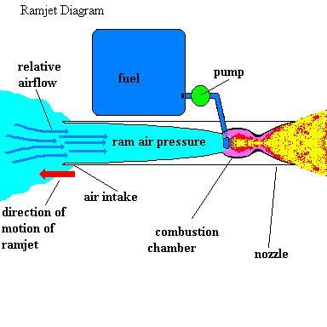
A ramjet has no moving parts and relies on the vehicle's speed to "ram" air into the inlet for compression. As the vehicle moves at high speed (typically Mach 2+), air rushes into the inlet. The inlet slows the air down and compresses it using shock waves. A shock cone creates shockwaves that slow incoming air to subsonic speeds before it enters the combustor.Fuel (usually liquid hydrocarbon) is injected. The compressed air mixes with fuel and burns. This dramatically increases temperature and pressure. Hence,enormous thrust is crated and the jet acquires insane speed. Because it cannot produce thrust at a standstill, it must be launched or boosted to supersonic speeds by another engine.Sometimes the turbofan engine and the ramjet engine in integrated in a single plane.
The Bramhos missile is operated on ramjet.

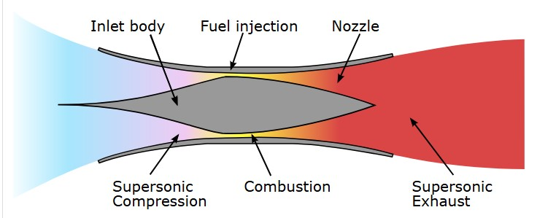
Scramjet (Mach 6 - 15+)https://www.grc.nasa.gov/www/k-12/airplane/scramjet.html
In a Scramjet (Supersonic Combustion Ramjet), the air remains supersonic throughout the engine. This is often described as "lighting a match in a hurricane" because the fuel must burn in a millisecond-fast supersonic stream. Scramjets use a converging inlet and oblique shockwaves to compress air without a shock cone, making them efficient at hypersonic velocities.

Engine Avionics: The FADEC System
Modern jet engines are managed by Full Authority Digital Engine Control (FADEC). 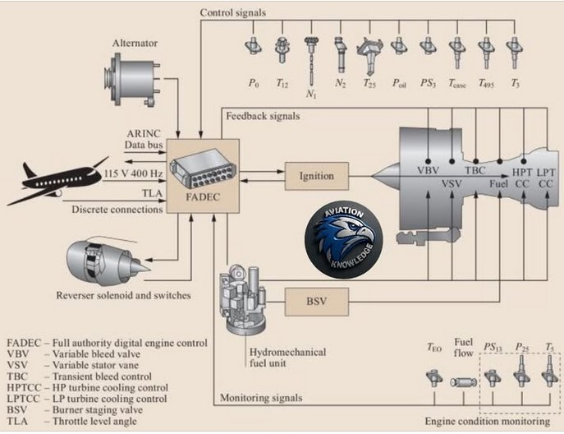

The Digital Brain
FADEC is an autonomous, dual-channel computer that evaluates inputs like air density, throttle position, and engine pressure up to 70 times per second. It automatically adjusts fuel flow and vane positions to ensure the engine provides maximum allowable power without exceeding structural or thermal limits.
Engine Health Monitoring (EHM)
A network of sensors provides data for predictive maintenance :
- N1 and N2: Rotational speeds of the Low-Pressure and High-Pressure spools.
- EGT (Exhaust Gas Temperature): The primary indicator of internal health; a rising EGT margin indicates wear.
- EPR (Engine Pressure Ratio): Measures the ratio of inlet to exhaust pressure to determine exact thrust output.
- Vibration Sensors: Detect subtle imbalances that may signal a cracked blade or bearing failure before it becomes catastrophic.

Summary Comparison of Aeronautical Propulsion Systems
Metric | Piston | Turbojet | Turbofan (High-Bypass) | Ramjet | Scramjet
Max Mach Number | ~0.6 | ~3.0 | ~0.9 | ~6.0 | ~15+
Combustion Type | Intermittent | Continuous | Continuous | Continuous | Supersonic
Moving Parts | High | High | High | None | None
Starting Ability | Static Start | Static Start | Static Start | Needs Boost | Needs Boost
Primary Advantage | Low cost | High Speed | High Efficiency | Simplicity | Hypersonic


SOURCES USED
researchgate.net
(PDF) The Development History of Planes Engine - ResearchGate
Opens in a new window

nasa.gov
The Power for Flight: NASA's Contributions to Aircraft Propulsion
Opens in a new window

safefly.aero
Exploring the Key Components of Modern Jet Engines: Insights from Safe Fly Aviation
Opens in a new window
phase-trans.msm.cam.ac.uk
Coatings for Turbine Blades
Opens in a new window

spartan.edu
The Evolution and Diversity of Aircraft Engines: From Propellers to Turbine
Opens in a new window

britannica.com
Jet engine - Turbofan, Turboprop, Ramjet | Britannica
Opens in a new window
grc.nasa.gov
How Jet Engines Work - Aeronautics Propulsion Research
Opens in a new window
grc.nasa.gov
Engines - NASA Glenn Research Center
Opens in a new window

reddit.com
Eli5, what's the difference between ramjet, scramjet, and turbojet? : r/explainlikeimfive - Reddit
Opens in a new window

en.wikipedia.org
Jet engine - Wikipedia
Opens in a new window

en.wikipedia.org
Turbofan - Wikipedia
Opens in a new window

blackjet.com
Types of Jet Engines Explained | Altitude Blog by BlackJet
Opens in a new window

publications.sto.nato.int
The Mission Defines the Cycle: Turbojet, Turbofan and ... - NATO
Opens in a new window
grc.nasa.gov
Turbofan Thrust
Opens in a new window
grc.nasa.gov
Turbofan Engine - NASA Glenn Research Center
Opens in a new window

aeroreport.de
How does a turbofan engine work? – The structure - AEROREPORT
Opens in a new window

nationalacademies.org
Read "Coatings for High-Temperature Structural Materials: Trends ...
Opens in a new window

jetplaneczx.medium.com
An Overview of Ramjet and Scramjet Propulsion | by Daniel Chen - Medium
Opens in a new window

engineering.purdue.edu
Ramjets and Scramjets - Purdue Engineering
Opens in a new window
grc.nasa.gov
Ramjet / Scramjet Thrust
Opens in a new window

en.wikipedia.org
Scramjet - Wikipedia
Opens in a new window

scholar.tecnico.ulisboa.pt
SCRAMJET and SHCRAMJET - Scholar
Opens in a new window

en.wikipedia.org
FADEC - Wikipedia
Opens in a new window

faa.gov
Full Authority Digital Engine Control (FADEC)
Opens in a new window

kureansiklopedi.com
Engine Health Monitoring System | KÜRE Encyclopedia
Opens in a new window

aopa.org
Turbine Pilot - AOPA
Opens in a new window
forums.x-plane.org
What are these - Aircraft Development Advice - X-Plane.Org Forum
Opens in a new window

baesystems.com
Full Authority Digital Engine Controls (FADEC) - BAE Systems
Opens in a new window

